**Nwheat to DSSAT:**

**Results as of Jan 31, 2013**

DSSAT NWheat files:

X-DSSAT45-Nwheat (02-05-2013)

(copied to C:\DSSAT45\Wheat\NWheat DSSAT files\Wheat)

FORTRAN NWheat files:

C:\NwheatCSM\Source (01-31-2013)

Potential production for the two models was determined using high levels of nitrogen fertilizer and water applications: 250 kg N spread across 3 applications, and 28 applications of 30 mm of water. DSSAT was run with water and N stress turned on, again to simulate the APSIM model which does not have a no-stress switch. For this approximation of potential production, the outputs of APSIM Nwheat and DSSAT Nwheat are very close. Among major growth and development indicators, the only noticeable discrepancy is LAI, which in the DSSAT version is slightly high during the latter half of the season (Appendix A).

Using the same environment and genotype, three levels of stress were compared:

1. Water application of 9 applications of 30 mm (68% reduction from potential version) and N application unchanged.
2. Water application reduced to 5 applications of 30 mm (82% reduction from potential version) and N application unchanged.
3. Water application of 5 applications of 30 mm; initial soil-water reduced from 0.212 to 0.111 in each level (47% reduction); and N application reduced to 70 kg/ha (72% reduction).

The graphic results of each of these are shown in Appendices B, C and D respectively. The analysis of the divergence of the DSSAT version is limited by the absence of some key variables in the APSIM Nwheat stressed-run output files. Of the three water-stress indices, only swdef(2) is available, and for the four N-stress indices, only nfact(2) is available. The daily outputs do not include stem weight (“stem_in_t” in previous APSIM Nwheat output files) or leaf weight (“leaf_wt” in previous APSIM Nwheat output files). The inclusion of these indices and variables in APSIM Nwheat output would assist in finding the source of the remaining discrepancies between the DSSAT and APSIM versions of Nwheat.

**Discussion of discrepancies between APSIM and DSSAT Nwheat models subjected to water and N stress**. (use material from [Nwheat Project log](NWheat%20Project%20Log.docx#Report_Material))

Stress index levels under abundant conditions: As would be expected, neither model indicated any water stress in the very-high-input “potential production” mode. However, even with abundant N applications, both models showed slight N stress during brief periods. APSIM Nwheat registered four days of slight N stress during the emergence phase. This may be the cause of slightly higher leaf and stem weights in DSSAT Nwheat compared to APSIM Nwheat, but even before stress disappears, plant part weights become equal in the two models. DSSAT Nwheat does not reproduce this surprising, early stress under abundant N conditions, but does show unexpected N stress during the last 4 days of the experiment. Since this stress occurs after max grain yield has been reached and LAI is at zero, it cannot be of any significance to plant growth or development. Note that the N amount within the tops and grain (last two graphs in Appendix A) for APSIM Nwheat is reproduced very well by DSSAT Nwheat.

1. Stress level 1: 68% reduction in water compared to potential version, but leaving N application unchanged. (APSIM Nwheat output file WS1_0.out and DSSAT fileX UFMX8902.WHX treatment #1. For graphs of results, see Appendix B.) LAI suffers more in APSIM Nwheat than DSSAT, so the main discrepancy in the potential version is aggravated. Grain yield is substantially higher in DSSAT Nwheat, although above ground weight seems to be higher only by the amount of grain weight (remember that no leaf or stem weights were provided for these runs of APSIM Nwheat, so I must guess about these plant parts). N stress shows no change compared to potential production for either model, so the discrepancies must be from water stress or N stress that is not reported in APSIM Nwheat outputs. Water stress begins earlier in DSSAT but then falls behind APSIM Nwheat water stress approximately the same time that DSSAT grain weight surpasses APSIM. The N content of the plant parts show an interesting tendency. Tops N is virtually identical in the two versions. Grain N however, ends substantially higher in DSSAT than APSIM. This over-concentration on N in DSSAT grain is compensated by lower N concentrations in DSSAT stem and leaf. This seems to point to a condition in DSSAT where excessive N is transferred from other plant parts, resulting in overproduction of grain. On the other hand, differing soil and water processes in the two models could also be playing a role in the models’ divergence.
2. Stress level 2: 82% reduction in water compared to potential version, but N application left unchanged. (APSIM Nwheat output file WS2_0.out and DSSAT fileX UFMX8902.WHX treatment #2.) The divergence of DSSAT Nwheat from APSIM is delayed at this stress level, with the LAIs coinciding quite closely through about DAP 84. After this however, the DSSAT version maintains a higher LAI than APSIM, and the versions diverge even more than in the lower-stressed runs. DSSATs over-estimation of grain that was noted at stress level 1 is much more noticeable at stress level 2, where DSSAT yield ends up over double APSIM yield. Again, most of the difference in above-ground weight is accounted for by grain weight alone. DSSAT also shows higher root weight. Water stress in the DSSAT version is consistently higher than in APSIM, possibly due to higher LAI and higher above ground growth. N stress is much higher in APSIM, which may be a reflection of the DSSATA version extracting N from plant parts at too-high a rate.
3. Stress level 3: 82% reduction in water compared to potential version, 47% reduction in initial soil water, and a 72% reduction in applied N. (APSIM Nwheat output file WN3_0.out and DSSAT fileX UFMX8902.WHX treatment #2.) The DSSAT version of Nwheat shows the highest possible level of water stress for 25 days from emergence. This apparently stunts the plant growth, which is consistently lower than the APSIM version. Only in final grain yield does DSSAT exceed the weight of APSIM. Again, this could reflect and exaggerated ability to pull N from other plant parts to support grain production. Water stress remains somewhat similar for the two versions, but N stress could not be more different, with DSSAT not capturing any of the considerable N stress that APSIM Nwheat shows. In this case, the stress may reflect in part the amount of N demanded: the N per plant part graphs in Appendix D show higher N concentrations in APSIM for all parts.

(Finally, I should provide some documentation on):

* Method used for transferring code
* Describe any aspects not described in either APSIM or DSSAT documentation
* List known problems (high LAI?)

**Appendix A**: Potential Production

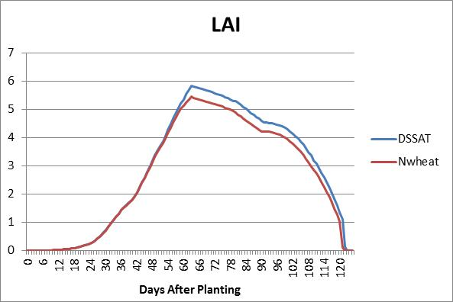

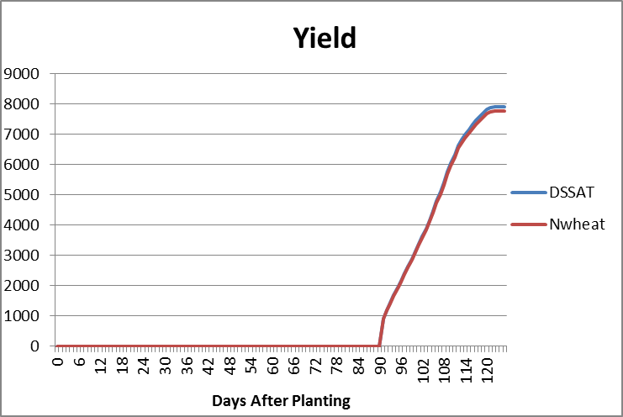

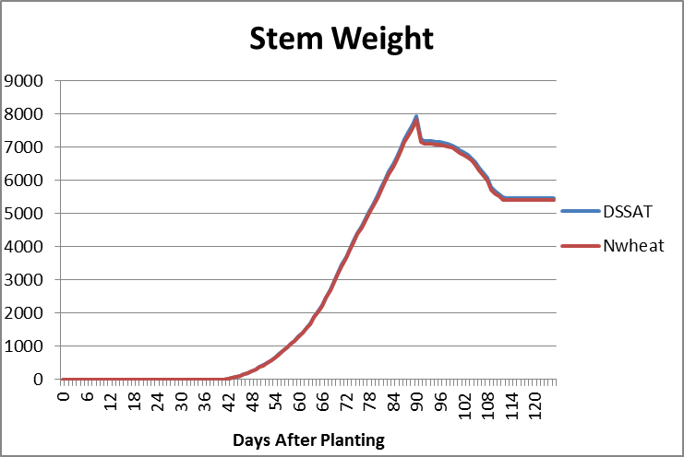

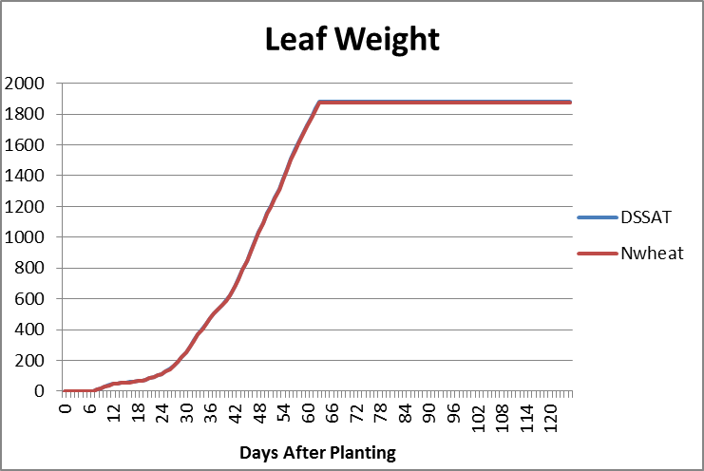

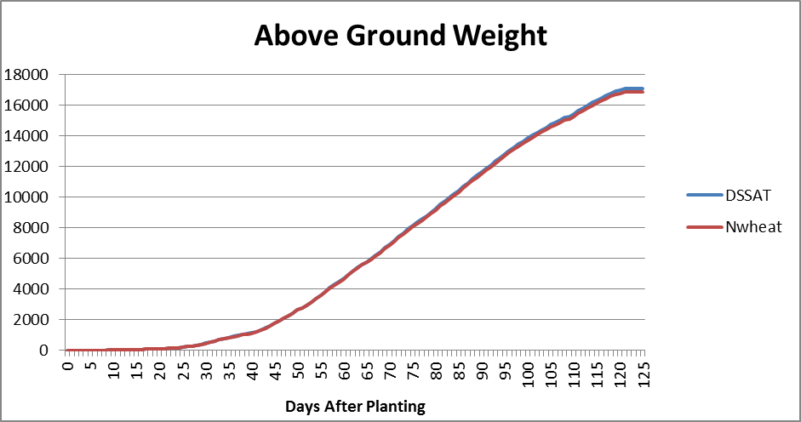

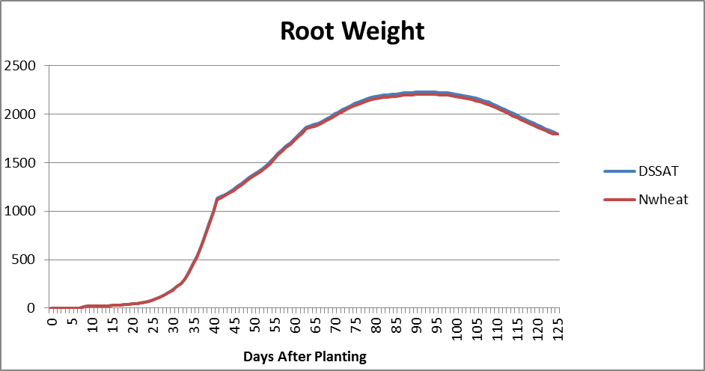

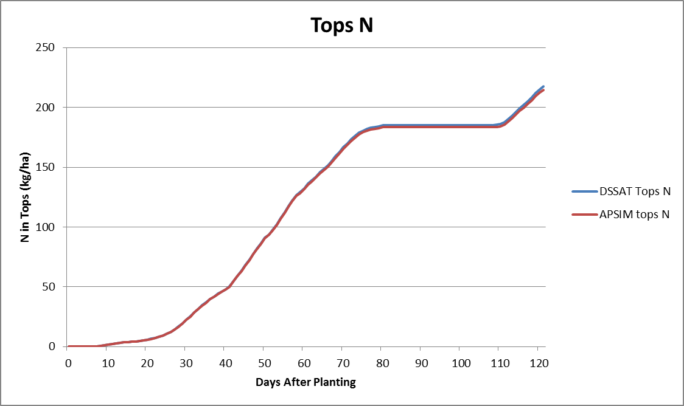

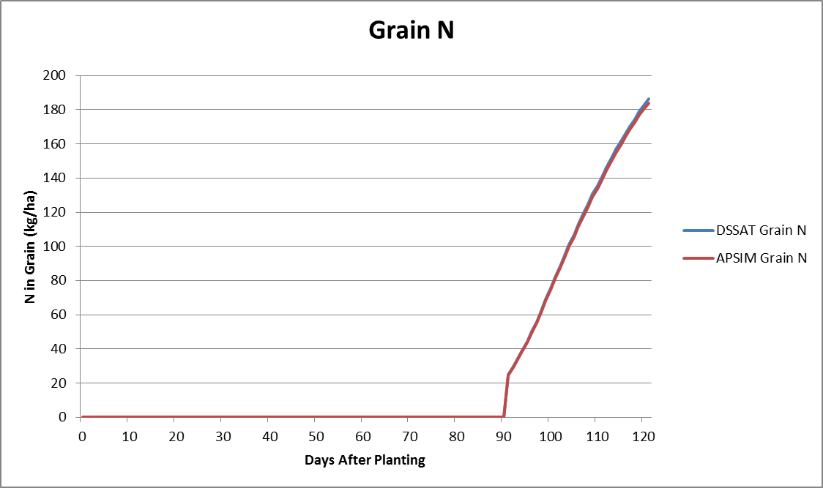

**Appendix B**.

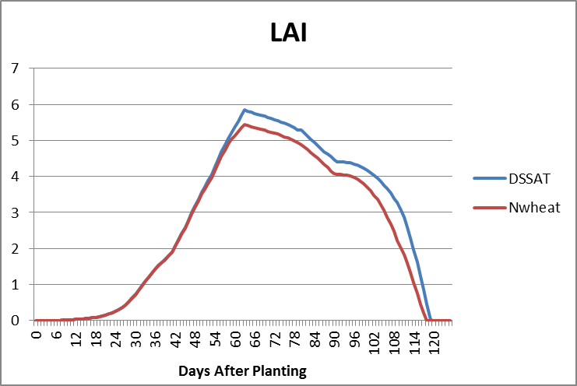

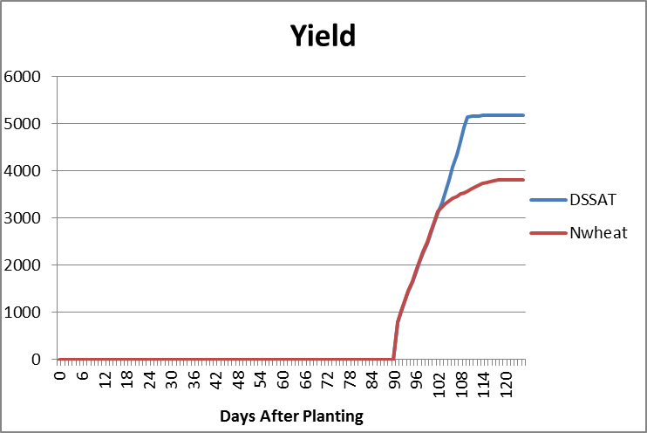

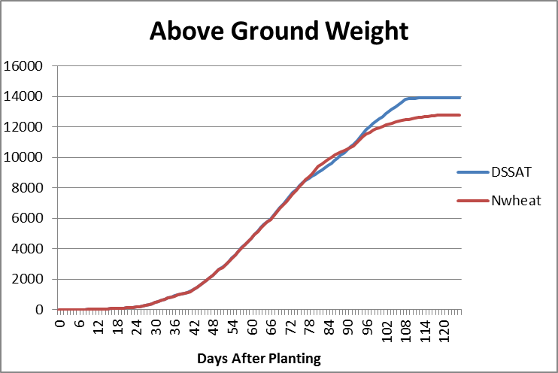

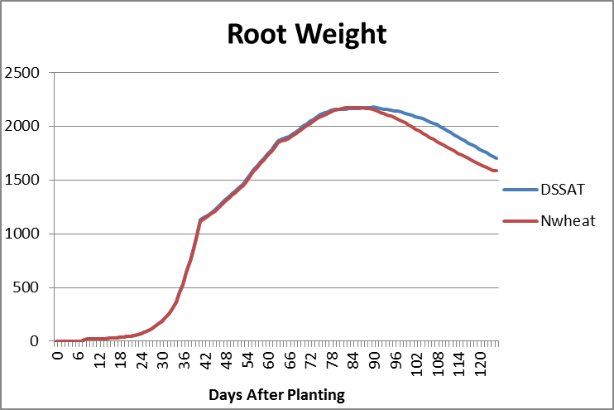

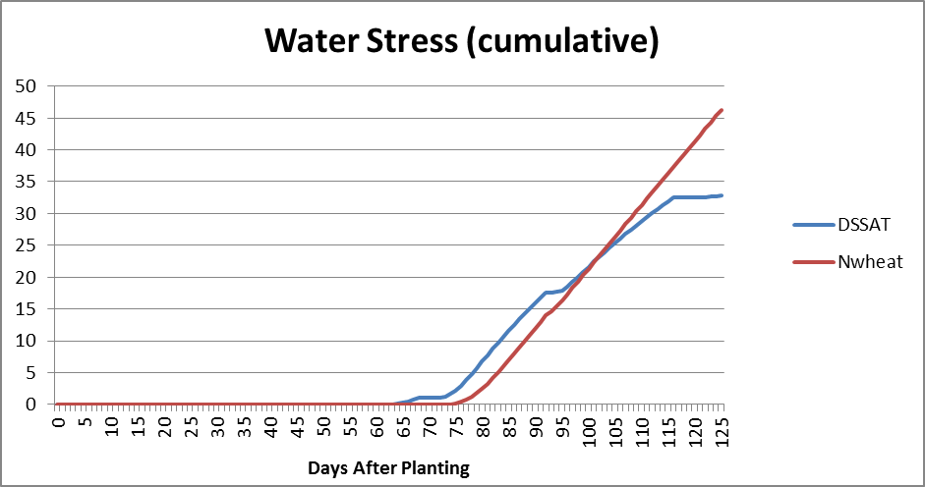

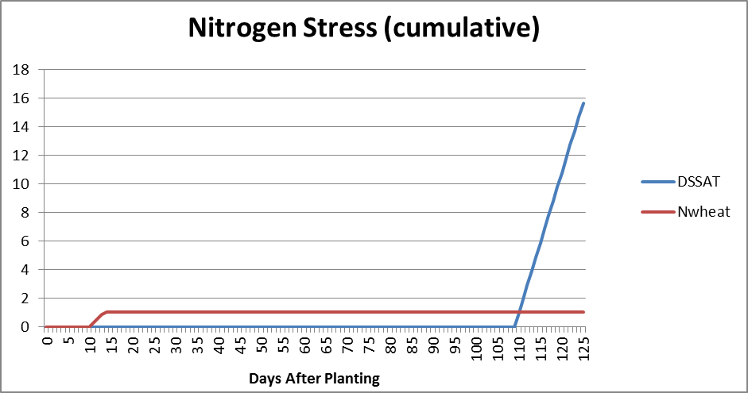

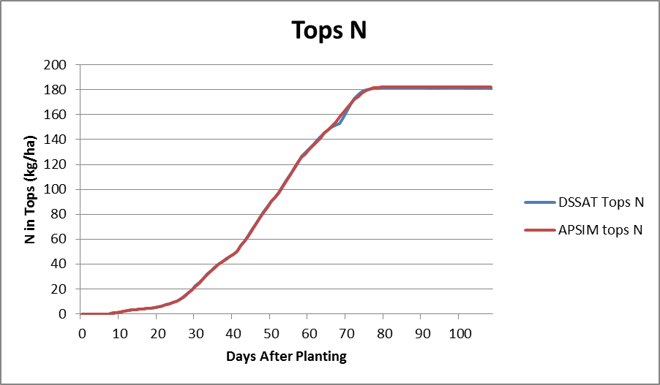

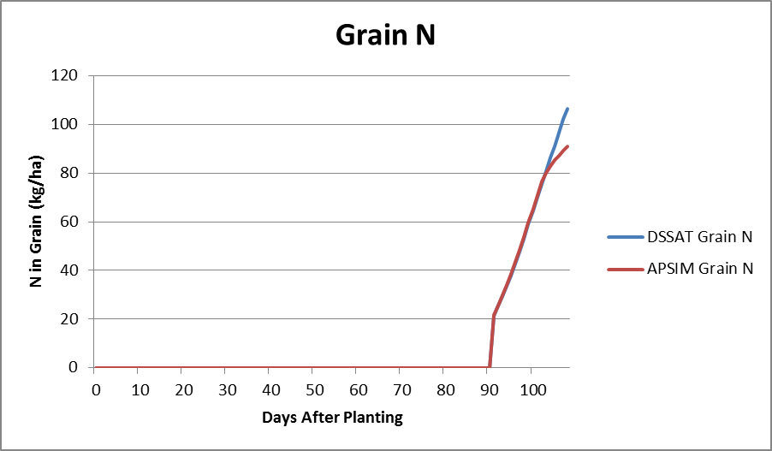

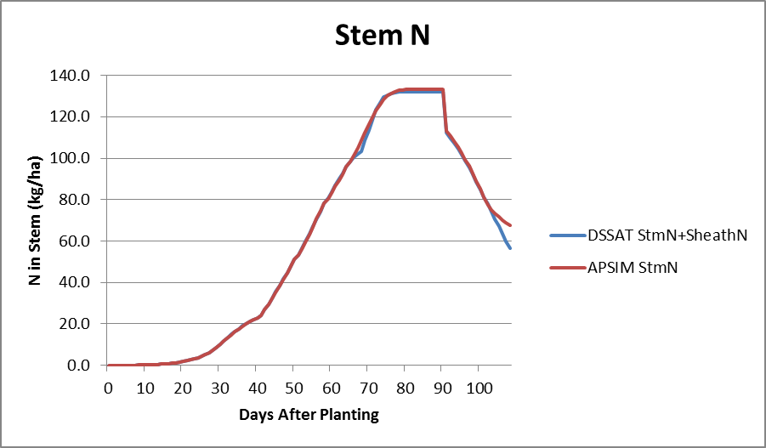

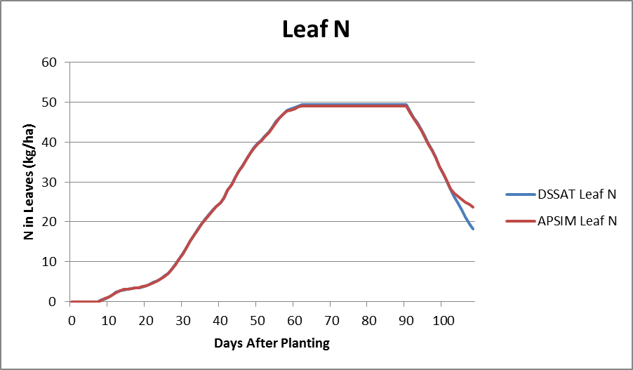

**Appendix C**.

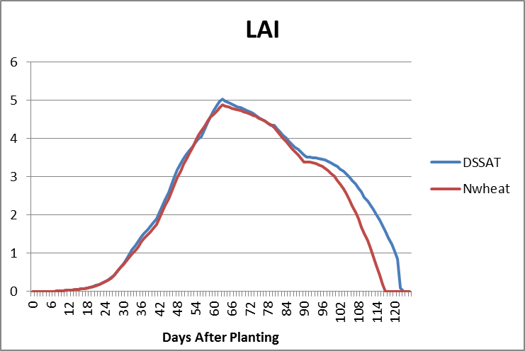

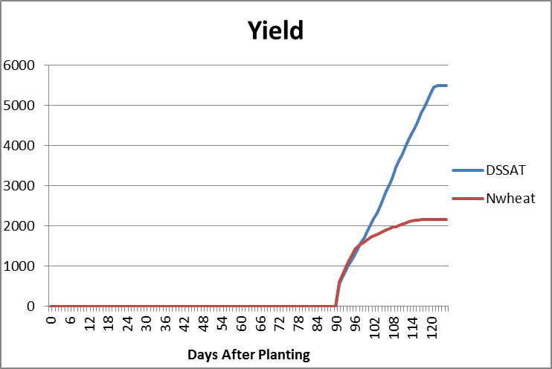

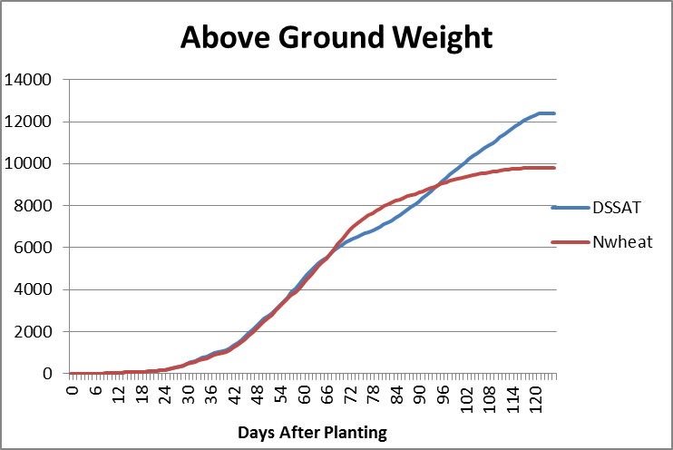

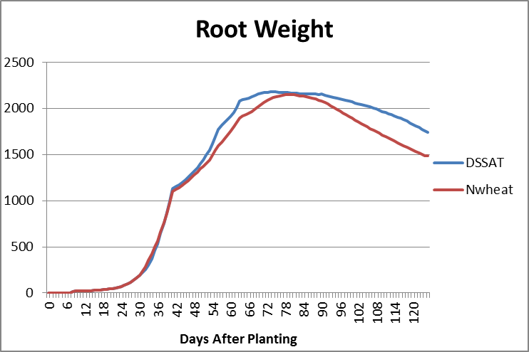

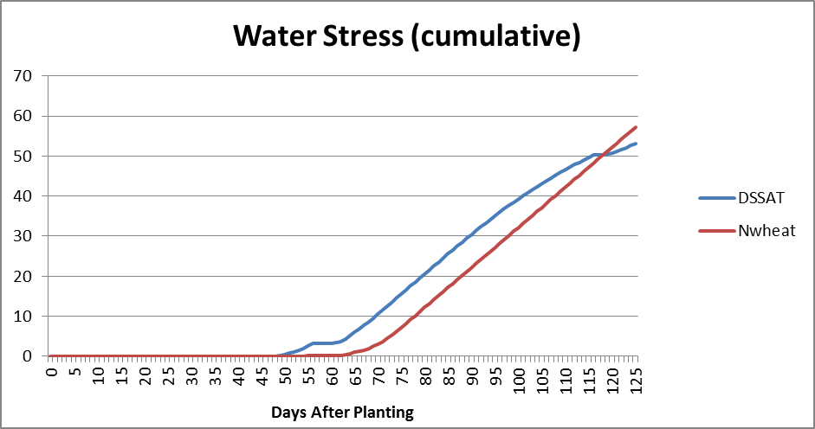

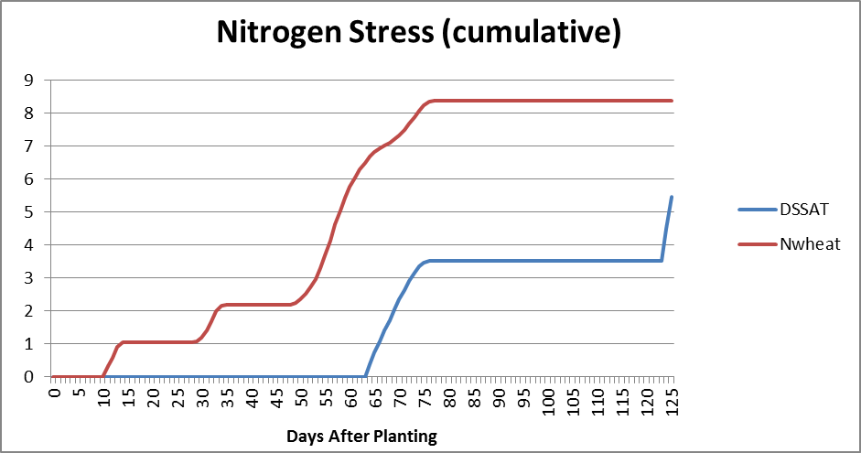

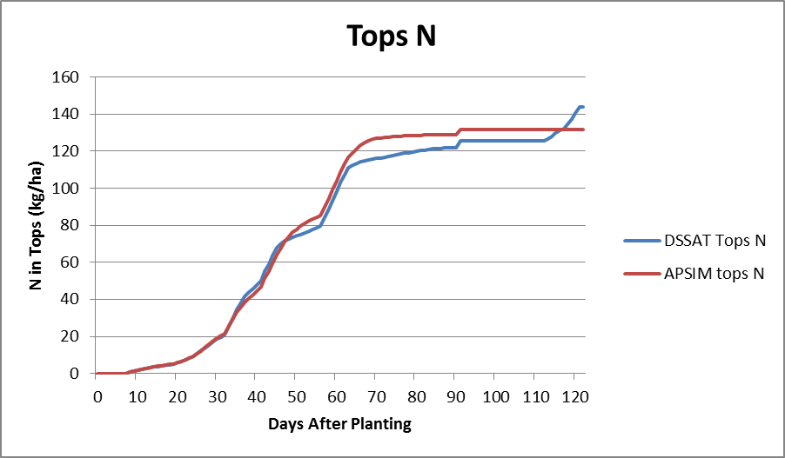

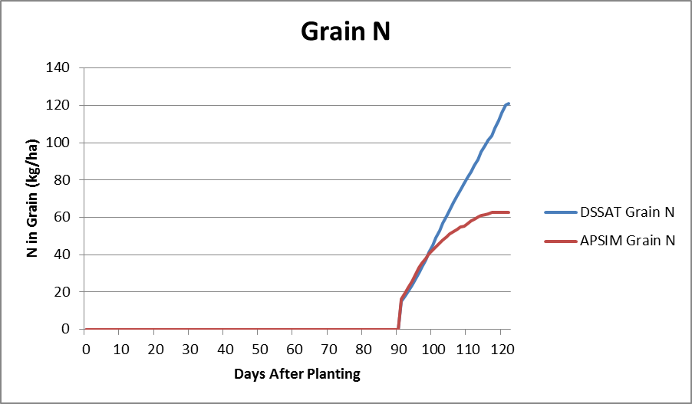

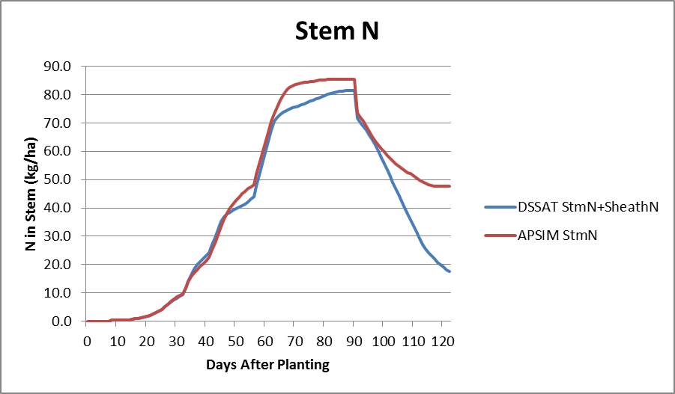

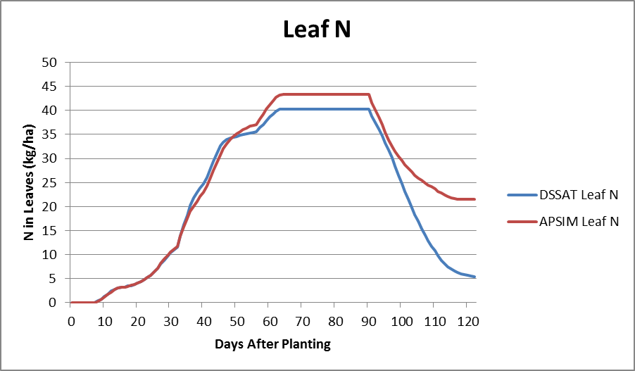

**Appendix D**.

